**Project Title: BalanceIQ  
Date: April 30, 2025**

**1. Project Overview**

**BalanceIQ is a unified platform designed to help users monitor and enhance their physical, mental, and emotional well-being. By consolidating diet, exercise, and mental health tracking into a single intuitive interface, the application empowers individuals to take control of their health and maintain a balanced lifestyle.**

**2. Business Needs**

**Key Challenges Addressed**

* Difficulty in capturing and correlating diverse wellness metrics in one place.
* Fragmented solutions for diet, fitness, and mental health tracking.
* Lack of clear, actionable insights into long-term health trends**.**

**Business Benefits**

* Increased user engagement through personalized dashboards and targeted recommendations.
* A scalable, high-performance platform capable of accommodating a growing user base and expanding data volumes.

**3. Stakeholders**

* Primary Users: Individuals seeking to track and improve their overall well-being.
* Administrators: Responsible for configuring the system, managing reference data, and generating reports on aggregated user metrics.
* Business Owners: Oversee strategic alignment of the platform with market needs and business objectives (planned for future releases).

**4. Functional Requirements**

**4.1 Holistic Health Tracking**

* Metric Recording: Allow users to log key health indicators (e.g., height, weight, blood pressure, heart rate).
* Trend Analysis: Provide interactive charts and graphs to visualize historical data and track progress over time.

**4.2 Diet Management**

* Meal Logging: Enable users to enter meals and snacks with portion details.
* Nutrition Insights: Integrate with the Nutritionix API to deliver real-time calorie counts and nutrient breakdowns.

**4.3 Activity Management**

* Activity Logging: Let users record workout sessions by selecting activity type and duration.
* Calorie Burn Estimates: Use external services (e.g., Nutritionix) to calculate calories burned based on logged activities.

**4.4 Mental Health Management**

* Mood & Stress Tracking: Allow users to record mood states, stress levels, and reflective journal entries.
* Relaxation Techniques: Offer tailored stress-management exercises and techniques via the GEMINI API**.(**Can be used in the future imprvements)

**4.5 User Dashboards**

* Personalized Dashboards: Present consolidated views of health metrics, dietary insights, exercise logs, and mental health entries in an interactive format.

**4.6 Reporting & Administration**

* Reference Data Management: Permit admins to define and maintain lists of health metrics, exercise types, and mood categories**.**

**5. Non-Functional Requirements**

* Performance: Ensure the system remains responsive under peak user loads.
* Scalability: Architect the solution to support future feature expansions and increased traffic.
* Security: Implement JWT-based authentication and follow best practices for data protection.
* Availability: Target 99.9% uptime to guarantee continuous access.
* User Experience: Design a responsive, accessible, and intuitive interface that works across devices.

**6. Technical Requirements**

* Backend: .NET Core with Entity Framework Core.
* Frontend: Angular framework enhanced with Toastr notifications.
* Database: Microsoft SQL Server.
* APIs: Nutritionix for dietary and exercise analytics; GEMINI for mental health recommendations.

**7. Database Design**

**Key Tables:**

* User: Stores user credentials and profile associations.
* Health Metrics: Defines available health metrics.
* Health Metric Log: Records individual metric entries per user.
* Activity Type: Lists admin-defined exercise categories.
* Activuty Log: Captures user workout details.
* Mood: Enumerates mood states tracked by the system.
* Mental Health Log: Logs mood entries and journal reflections.
* Diet: Records meal logs along with nutritional data retrieved from external APIs.

**8. Block Diagram**

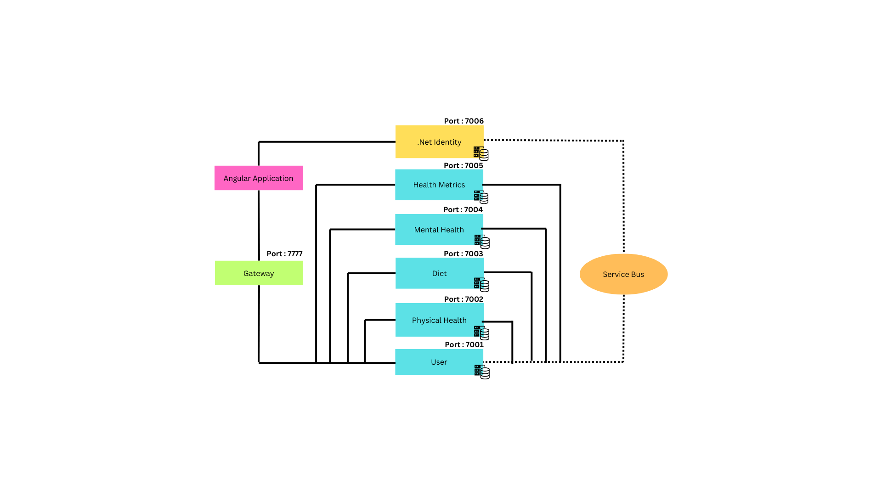

**9. Flow Chart**

